Отчет по лабораторной работе № 3
по курсу «Математическое моделирование»
«Моделирование задачи теплопроводности»

Выполнил: студент 4 курса группы ПМИ-22
Архипов Василий Олегович

Якутск, 2025
Постановка задачи
Математическая модель:
$$\frac{∂T}{∂t}=∇∙(λ(x, y)∇T)$$
Коэффициенты:
$$λ\left(x,y\right)=1+0.1x-0.2y$$
Начальные условия:
$$T_{0}=15$$
Граничные условия:
$$T=10 на верхней и нижней грани$$
$$\frac{∂T}{∂n}=0 на левой и правой грани$$
Конечно-элементная аппроксимация
$$\frac{∂T}{∂t}≈\frac{T^{n+1}-T^{n}}{τ}$$
$$\int_{Ω}{\frac{∂T}{∂t}vdx}+\int_{Ω}{λ(∇T, ∇v)dx}=0$$
$$\int_{Ω}{\frac{T^{n+1}-T^{n}}{τ}vdx}+\int_{Ω}{λ(∇T^{n+1}, ∇v)dx}=0$$
Линейная и билинейная форма:
$$a=\int_{Ω}{\frac{T^{n+1}}{τ}vdx}+\int_{Ω}{λ(∇T^{n+1}, ∇v)dx}$$
$$L=\int_{Ω}{\frac{T^{n}}{τ}vdx}$$

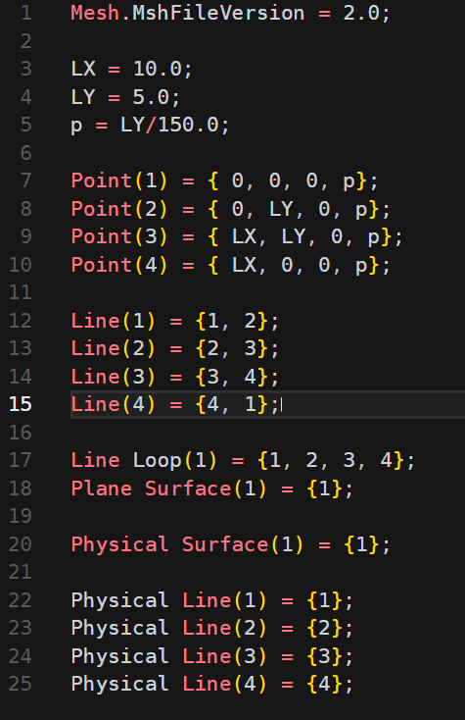
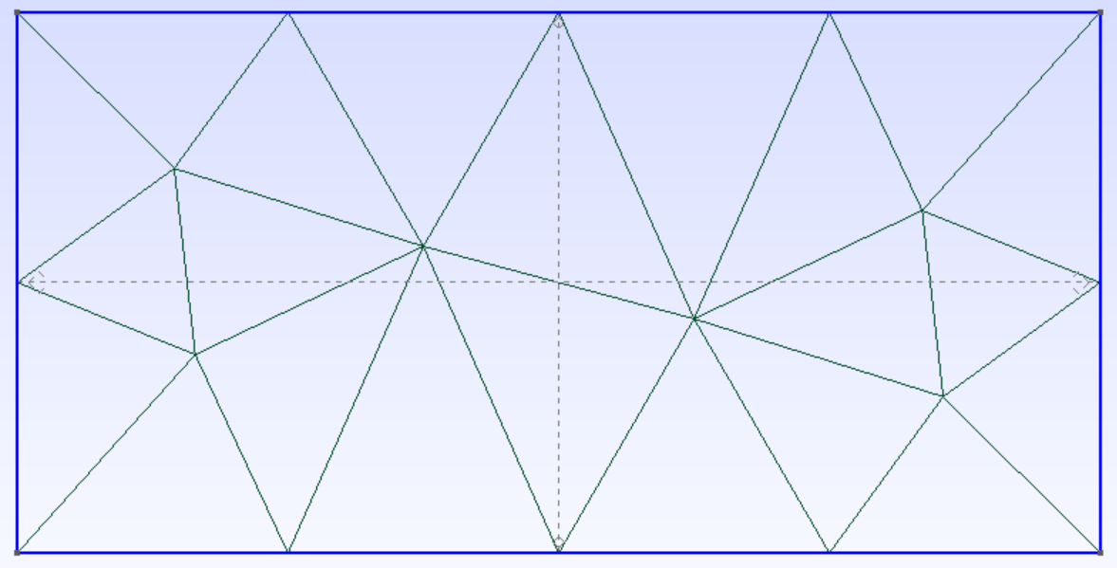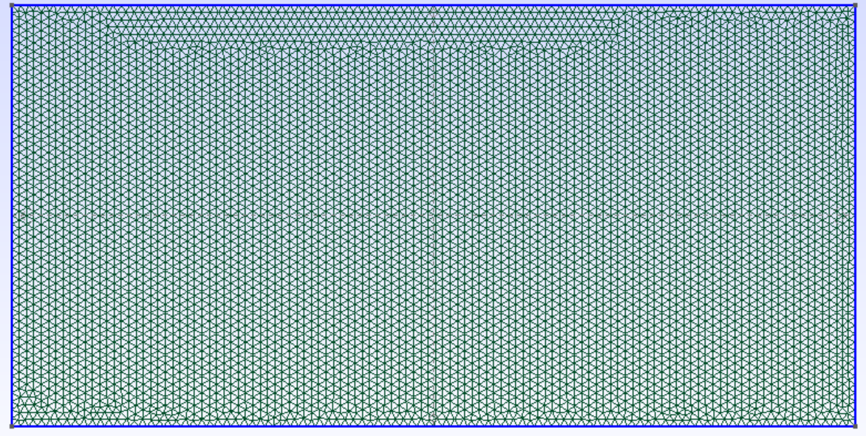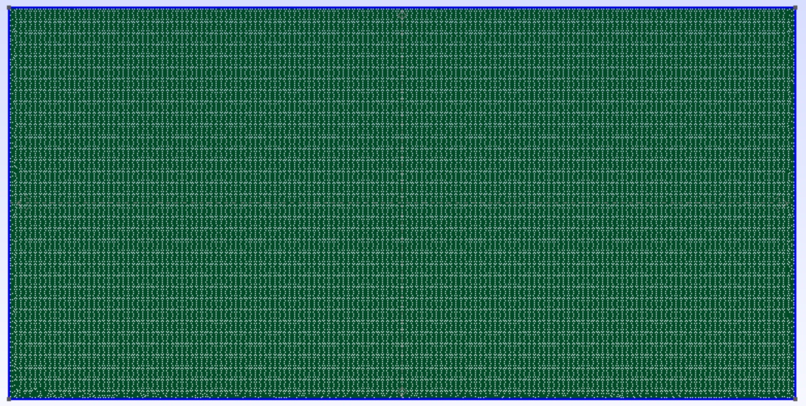
3 сетки с разной кучностью

from dolfin import *

meshname = "mesh1"
mesh1 = Mesh(meshname + ".xml")
subdomains1 = MeshFunction("size_t", mesh1, meshname + "_physical_region.xml")
boundaries1 = MeshFunction("size_t", mesh1, meshname + "_facet_region.xml")

meshname = "mesh2"
mesh2 = Mesh(meshname + ".xml")
subdomains2 = MeshFunction("size_t", mesh2, meshname + "_physical_region.xml")
boundaries2 = MeshFunction("size_t", mesh2, meshname + "_facet_region.xml")

meshname = "mesh3"
mesh3 = Mesh(meshname + ".xml")
subdomains3 = MeshFunction("size_t", mesh3, meshname + "_physical_region.xml")
boundaries3 = MeshFunction("size_t", mesh3, meshname + "_facet_region.xml")

V1 = FunctionSpace(mesh1, "CG", 1)
V2 = FunctionSpace(mesh2, "CG", 1)
V3 = FunctionSpace(mesh3, "CG", 1)

dx1 = Measure('dx', domain=mesh1, subdomain_data=subdomains1)
ds1 = Measure('ds', domain=mesh1, subdomain_data=boundaries1)
dx2 = Measure('dx', domain=mesh2, subdomain_data=subdomains2)
ds2 = Measure('ds', domain=mesh2, subdomain_data=boundaries2)
dx3 = Measure('dx', domain=mesh3, subdomain_data=subdomains3)
ds3 = Measure('ds', domain=mesh3, subdomain_data=boundaries3)

T_max = 6
N = 50
tau = T_max / N
dt = 0

g_T = Constant(10.0)
g_B = Constant(10.0)
lmd = Expression("1 + 0.1*x[0] - 0.2*x[1]", degree=1)

bc_1_V1 = DirichletBC(V1, g_T, boundaries1, 2)
bc_2_V1 = DirichletBC(V1, g_B, boundaries1, 4)
bcs1 = [bc_1_V1, bc_2_V1]

bc_1_V2 = DirichletBC(V2, g_T, boundaries2, 2)
bc_2_V2 = DirichletBC(V2, g_B, boundaries2, 4)
bcs2 = [bc_1_V2, bc_2_V2]

bc_1_V3 = DirichletBC(V3, g_T, boundaries3, 2)
bc_2_V3 = DirichletBC(V3, g_B, boundaries3, 4)
bcs3 = [bc_1_V3, bc_2_V3]

T1 = TrialFunction(V1)
v1 = TestFunction(V1)
T2 = TrialFunction(V2)
v2 = TestFunction(V2)
T3 = TrialFunction(V3)
v3 = TestFunction(V3)

T0_val = Constant(15.0)
T0_1 = interpolate(T0_val, V1)
T0_2 = interpolate(T0_val, V2)
T0_3 = interpolate(T0_val, V3)

a1 = (T1/tau)*v1*dx1 + lmd*inner(grad(T1), grad(v1)) * dx1
L1 = (T0_1/tau)*v1*dx1
a2 = (T2/tau)*v2*dx2 + lmd*inner(grad(T2), grad(v2)) * dx2
L2 = (T0_2/tau)*v2*dx2
a3 = (T3/tau)*v3*dx3 + lmd*inner(grad(T3), grad(v3)) * dx3
L3 = (T0_3/tau)*v3*dx3

T1 = Function(V1)
T2 = Function(V2)
T3 = Function(V3)
file1 = File("/mnt/c/Users/Vasya/Downloads/temperature1.pvd")
file2 = File("/mnt/c/Users/Vasya/Downloads/temperature2.pvd")
file3 = File("/mnt/c/Users/Vasya/Downloads/temperature3.pvd")
error_file1 = open("/mnt/c/Users/Vasya/Downloads/error_data1.dat", "w")
error_file2 = open("/mnt/c/Users/Vasya/Downloads/error_data2.dat", "w")
while dt < T_max:
dt += tau
solve(a1 == L1, T1, bcs1)
solve(a2 == L2, T2, bcs2)
solve(a3 == L3, T3, bcs3)
T1.rename('T1', '0')
T2.rename('T2', '0')
T3.rename('T3', '0')
file1 << T1
file2 << T2
file3 << T3

T1_on_V3 = interpolate(T1, V3)
E2_t_1 = inner(T3 - T1_on_V3, T3 - T1_on_V3)*dx3
E2_b_1 = inner(T3, T3)*dx3
E2_1 = sqrt(abs(assemble(E2_t_1))/abs(assemble(E2_b_1)))

T2_on_V3 = interpolate(T2, V3)
E2_t_2 = inner(T3 - T2_on_V3, T3 - T2_on_V3)*dx3
E2_b_2 = inner(T3, T3)*dx3
E2_2 = sqrt(abs(assemble(E2_t_2))/abs(assemble(E2_b_2)))

error_file1.write(f"{dt} {E2_1}\n")
error_file2.write(f"{dt} {E2_2}\n")
T0_1.assign(T1)
T0_2.assign(T2)
T0_3.assign(T3)
error_file1.close()
error_file2.close()
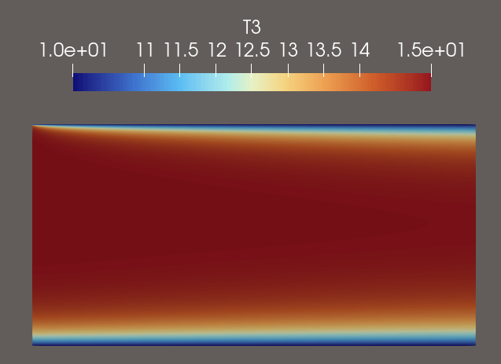
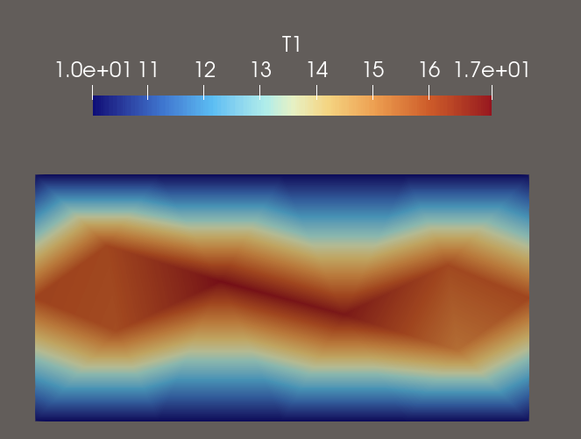
Для вычисления погрешности я использовал L2 погрешность
В качестве эталонного решения я взял mesh3, mesh1 это самая грубая сетка
set terminal png size 800,600
set output "error_plot.png"
set xlabel "Время"
set ylabel "L2 погрешность"
set title "Зависимость погрешности от времени"
set grid

plot "error_data1.dat" with linespoints title "Погрешность 1", \
"error_data2.dat" with linespoints title "Погрешность 2"
